**Name/ هاني شاكر محمد سيد احمد حسن**

**B.N/ 1015**

**Topic/ operating systems**

**GitHub-link:** <https://github.com/hany-shaker/html-project-repository>

**Brief about the topic:** <https://hany-shaker.github.io/html-project-repository/>

**Operation system**

The operating system is a mediator which connects between the person using the computer and the computer hard ware by creating an environment in which a user can execute the program efficiently and conveniently.

An operating system is software which manages the computer hardware. It is a program that controls the execution of applications and works as an interface between the user of a pc and the laptop hardware. It always runs all the time when the computer is on.

The operation system allocates service and resources such as processors, memory, devices, and information. It has a required program for managing those resources such as memory management module, a scheduler a traffic controller, a file system and I/O programs.

It does basic jobs such as responding input from the keyboard and other input devices, keeping directories and track of folder on the hard disk; it is responsible for sending output to monitor and managing minor devices.

**Applications of operating system**

The operating system include systems program, tools and software such as windows, Linux, Mac OS, Unix, MS-DOS, FreeRTOS, Bsd and debian which responsible for Low-level processes and operational support system. These systems provide a suitable environment for user.

**Screenshots:**

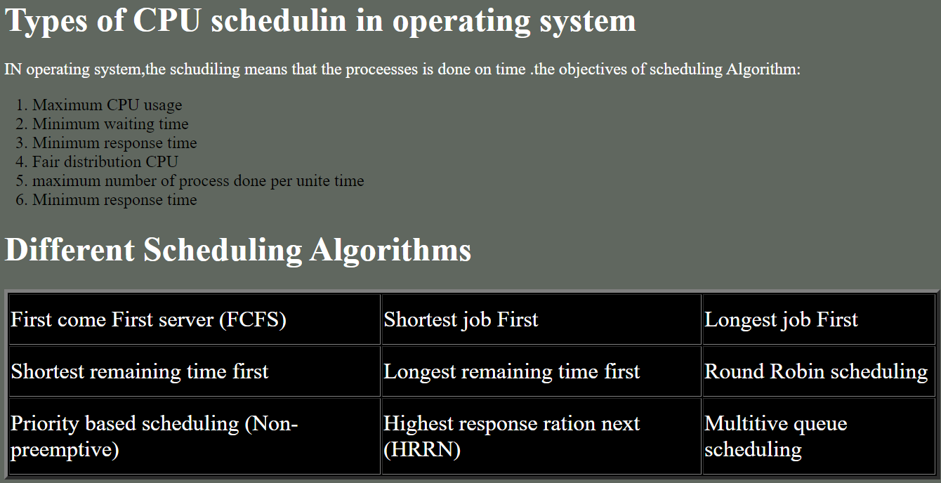

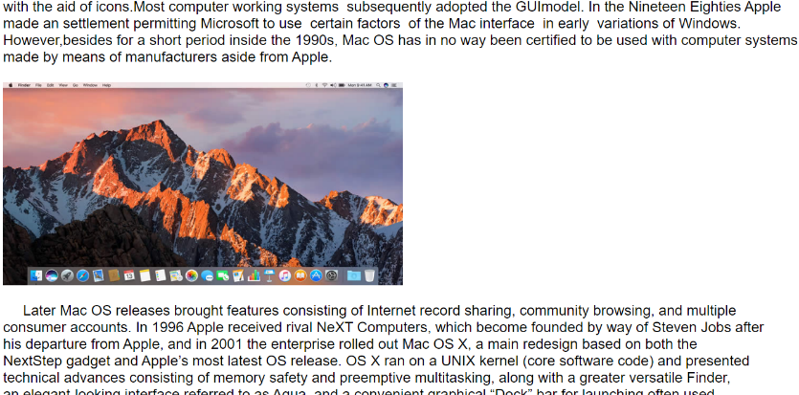

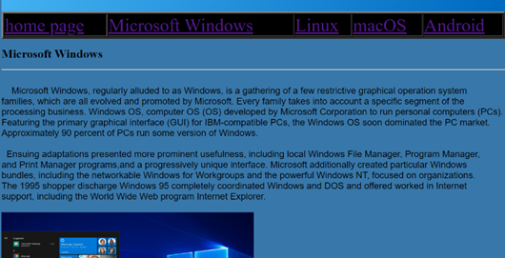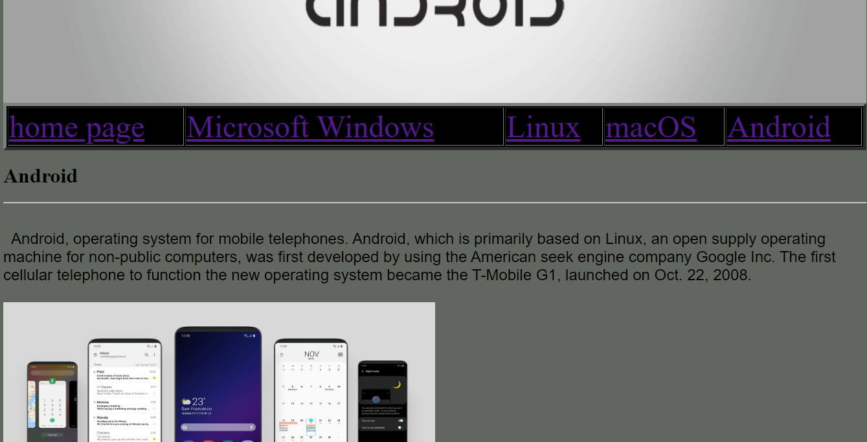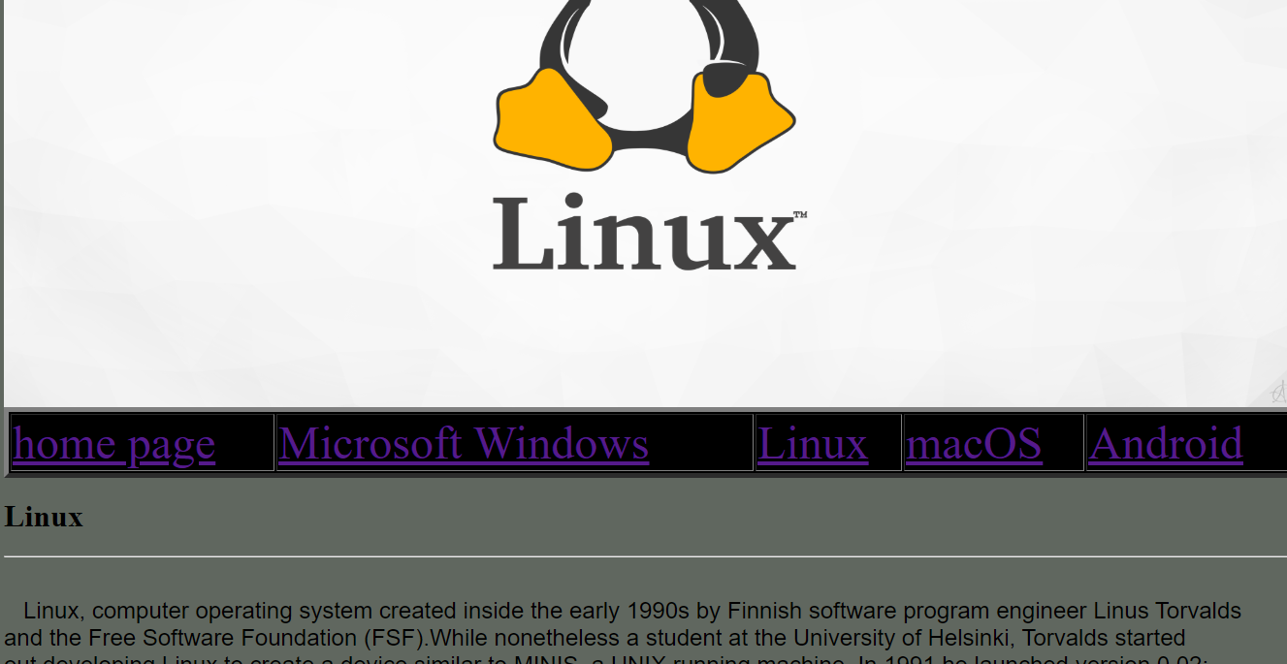

**Source code:**

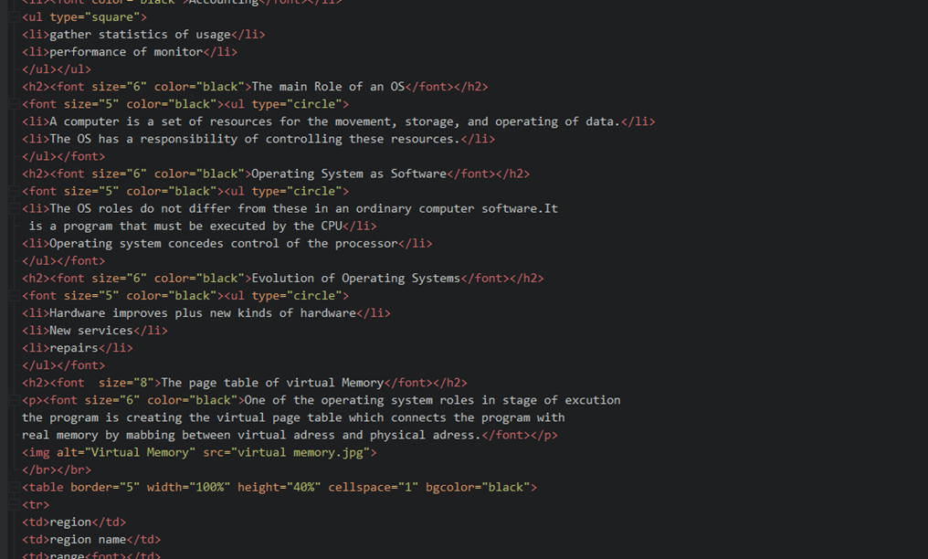

**References**

Stallings, W. (2008). *Operating systems: Internals and design principles*. Harlow: Pearson Education.

Geeksforgeeks. (2019, August 28). Introduction of Operating System - Set 1. Retrieved May 22, 2020, from <https://www.geeksforgeeks.org/introduction-of-operating-system-set-1/>

Geeksforgeeks. (2020, February 4). Functions of Operating System. Retrieved May 23, 2020, from <https://www.geeksforgeeks.org/functions-of-operating-system/>

Geeksforgeeks. (2019, August 14). Types of Operating Systems. Retrieved May 23, 2020, from <https://www.geeksforgeeks.org/types-of-operating-systems/>

GeeksForGeeks. (2019, July 23). CPU Scheduling in Operating Systems. Retrieved May 23, 2020, from <https://www.geeksforgeeks.org/cpu-scheduling-in-operating-systems/>

GeeksForGeeks. (2019b, August 16). Virtual Memory in Operating System. Retrieved May 23, 2020, from <https://www.geeksforgeeks.org/virtual-memory-in-operating-system/>

Microsoft Windows 2020. *Britannica Academic*. Retrieved 29 May 2020, from <https://061070crz-1105-y-https-academic-eb-com.mplbci.ekb.eg/levels/collegiate/article/Microsoft-Windows/438620>

Linux 2020. *Britannica Academic*. Retrieved 29 May 2020, from <https://061070crz-1105-y-https-academic-eb-com.mplbci.ekb.eg/levels/collegiate/article/Linux/438614>

Mac OS 2020. *Britannica Academic*. Retrieved 29 May 2020, from <https://061070crz-1105-y-https-academic-eb-com.mplbci.ekb.eg/levels/collegiate/article/Mac-OS/438615>

Android 2020. *Britannica Academic*. Retrieved 29 May 2020, from <https://061070crz-1105-y-https-academic-eb-com.mplbci.ekb.eg/levels/collegiate/article/Android/471434>